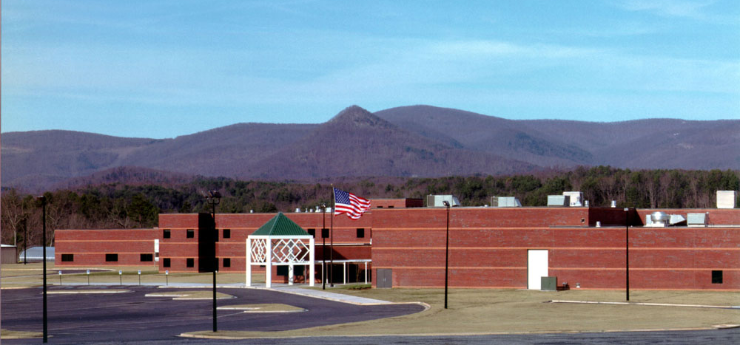
_
500 Dragon Drive
Jasper, GA 30143
Hosted by
Pickens County
High School
June 26-28, 2024
17th Annual
State Conference
REGISTRATION
All youth and adults must be registered with either Learning for Life or the Public Safety Cadets to attend the conference. Each Post or Unit attending the conference must be a current member of the Law Enforcement Experience Association of Georgia. If they are not a current member, they will have the opportunity to join when registering for the conference.
Each Post or Unit must follow their programs’ guidelines and be current on their annual youth protection training. The attendance capacity for each state conference is dictated by facilities and space at the host venue. The attendance limit for each conference is usually achieved very quickly following the opening of the registration period; therefore, agencies are strongly encouraged to register for the conference as soon as possible. Registration for the conference is on a first-come, first-served basis; registrations will not be accepted once conference capacity has been attained.
Leaders are requested to carefully complete all conference forms (See Forms to be Completed at the end of this packet) as incomplete forms or inaccurate information will delay processing and may result in a Post not being registered in time to attend the conference.
If the Advisor has any questions or issues with completing the registration they should contact either Major W. Furman at 678-382-6920 (william.furman@dunwoodyga.gov ), or Lt. C. Leake at (cleake@pickensgasheriff.com ).

INSTRUCTIONS
- Complete the Registration and Competition Registration form. Make sure to include if you will have any youth competing in the pistol, P/T, or drill competition. The youth DO NOT have to be part of a team to compete in the pistol, P/T, or drill event.

- If your program would like to nominate an Explorer or Cadet for Youth President, Regional Vice-President or for State Chaplin, please complete the Nomination Form. It is important to put your Region on the Nomination Form (See last page of this packet for your region.)

- EMail your Registration Form to william.furman@dunwoodyga.gov PDF versions are accepted and encouraged!
Registration payment can be made online at https://www.leeag.org/leeag-store.html
If you need to pay by check make checks payable to L.E.E.A.G. and bring to conference.

- Review with your Explorers and Cadets the Code of Conduct prior to leaving for the event.

- Adults AND youth must sign the Covenant Not To Sue and Code of Conduct. These forms are to be brought with you when you check-in.

FREQUENTLY ASKED QUESTIONS

Q: What is a Delegate and do I need to pick two?

A: The Delegates are the two youth within your post that will be allowed to vote for the State Officers. If your post does not pick two delegates, then you will not have votes for the state positions. Delegates can be changed up to and including at check in. Once your Post checks in you will not be able to change your delegates.

Q: What if I don't bring as many youth as I sent in my registration?

A: Refunds can be given if the updated registration is received at least two weeks before the start of the conference.

ACCOMODATIONS
Lodging
Lodging will be the responsibility of individual agencies.

Meals
Lunch will be provided on Wednesday and Thursday in the cafeteria.

PROCEDURES AND RULES
Adult Leadership
As previously mentioned, each program attending the conference must have, at a minimum, two adult leaders both of whom must be at least 21 years of age. Programs with coed delegations must have at least one male and one female adult leader. At least two adult leaders for each program are at all times expected to be onsite and provide oversight and supervision to the youth for which they are responsible. Adult leaders must respond to any matters involving their youth referred to them by conference staff.
All adult leaders must conduct themselves in a professional manner that is in accordance with the Law Enforcement Code of Ethics and the Conference Code of Conduct. Inappropriate or illegal behavior by an adult leader will result in immediate notification to the chief, sheriff or head of the sponsoring agency and, if required, local authorities. Any unacceptable behavior may also result in the leader being removed from the conference.
Attire, Uniform and Equipment Requirements
The dress code for the conference will vary by activity or event. Youth participating in team competition events should be in uniform and may elect to wear their duty/training (i.e., Class B) uniform for this purpose.
The Post/Unit uniform is to be worn for the opening program on Tuesday evening and the closing program on Friday morning. Adult leaders may attend the shows in their department uniform or business casual attire.
Generally speaking, youth and adult leaders may wear casual, but appropriate, attire during the conference. Youth and adult leaders are encouraged to include in their casual attire shirts or other clothing, items that identify them as being associated with their sponsoring agency, Law Enforcement Exploring, Public Safety Cadets or other law enforcement group or organization.
The conference, because of its unique nature and the dedicated adults and impressive youth who participate in the program, always draws the interest of the news media that may be on site to observe conference events, take photos/videos and conduct interviews. Participants are asked to be mindful that the media and special visitors to the conference will take notice of their dress and demeanor and to act accordingly.
Youth are not to carry any law enforcement equipment on their uniform belt, or on their person, except while participating in team competition events, training seminars and walking to and from those events. The only law enforcement equipment/accessories youth are permitted to have with them during team competitions are a flashlight, handcuffs, holster, gloves, whistle, pen/pencil, and a notepad. If the sponsoring agency provides, or an youth has his/her own, inert pistol (i.e., Red Handle pistol, Blue Gun) to use for training or competition they may only be carried during the competitive event or seminar training.
Additionally, youth are not permitted to carry offensive or defensive weapons to include firearms, Tasers, nightsticks, batons (collapsible or otherwise), saps or sap gloves, tactical flashlights (i.e. large metal or other heavy duty material flashlights that may be used as a nightstick or baton), knives, chemical repellents or electrical shock devices.

TEAM COMPETITIONS AND SEMINARS
One of the most popular activities at every state conference is the team and individual competitive events. All competition at the conference is presented with an emphasis on participation, skill enhancement and good sportsmanship. The conference competition is intended to foster the development of individual and team growth through personal, physical and group challenges in an environment of learning and enjoyment.

This year’s conference will offer several competitive team events on Wednesday. These include:
Traffic Stop
Domestic Dispute
Unknown Trouble
Active Shooter
Business Dispute
Officer Rescue
This year we will also host two individual events that your youth may register for. These events will receive their own trophies and the scores will not be counted in the overall State Champion total. These events are:
These events will compete on Wednesday from 1000 hrs to 1700 hrs
Fitness Challenge
Pistol Competition

The overall State Champion will be awarded based on the total score from the team events.

TEAM COMPETITION DESCRIPTIONS
Event: Traffic Stop
Scenario: The team will be graded on their ability to deal with the potentially dangerous situation with regard to effecting the stop of the vehicle; approaching the vehicle with care; courtesy; completeness in interviewing the occupants; reacting to the unknown; and recognizing the need to call for a backup unit.
Event: Domestic Dispute
Scenario: Two patrol officers have been assigned to respond to an unknown domestic disturbance. Another patrol car is available as a backup. Upon arrival, the first two youth are faced with a classic domestic confrontation. Scoring will be based on how well teams handle this potentially dangerous situation.
Event: Unknown Trouble
Scenario: Teams will be dispatched to a 911 hang up call with very little information provided. They must respond appropriately to the scene they encounter and successfully resolve the situation.
Event: Active Shooter
Scenario: The team is the first to arrive on the scene of an active shooter. They are provided with basic information about the possible suspect and then released into the scene. They must successfully locate and eliminate the threat.
Event: Business Dispute
Scenario: Teams will be dispatched to a business dispute with minimal information. They must respond to the scene and conduct the appropriate interviews to determine the correct resolution.
Event: Officer Rescue
Scenario: The team will need to extract a downed officer and render the appropriate life saving medical aid (i.e. tourniquet, wound packing, etc).

INDIVIDUAL COMPETITION EVENT DESCRIPTIONS
Event: Physical Agility Test
All conference participants are eligible to individually compete in this event. Awards will be presented to the top three male and top three female youth.
The Police Physical Fitness Test is a series of physical fitness challenges that correlate to the ability to perform day-to-day police functions. Such challenges may include, but are not limited to, running, pull-ups, push-ups, sit-ups, and obstacle course. Each aspect of the test will be measured in terms of performance and cumulative time standards to determine score. Participation in this test will provide the youth with insight and experience into law enforcement physical fitness testing and the opportunity to measure their personal physical fitness against other participants in their respective age category.
Event: Pistol Competition
Youth will need to have completed either the NRA Law Enforcement Explorer Qualification, or 5 hours of classroom training and have shot 100 rounds of ammunition under the direction of a certified firearms instructor. That firearms instructor will need to sign the authorization form outlining the training the youth received.
The attached form will need to be signed by a certified firearms instructor declaring that the youth has completed the required basic training.

SEMINAR TRAINING
A selection of exciting and informative law enforcement related seminars will be offered to all conference participants. Subject matter experts from various local, county, state and federal law enforcement agencies or organizations present these seminars. Pre-registration is required for attendance in the seminars. The youth will be allowed to attend three training seminars that are two and one half (2 ½) hours long on Friday.
The adult leader will register their youth through the online portal. They will receive the instructions on how to do so after the registration packet has been received at LEEAG. The classes fill on a first served bases. Once a class’s capacity has been reached, the class will be locked and the youth will have to choose an alternate.
The training seminars for this year are:
Job Preparation
Court Room Testimony
K-9
Stop the Bleed
Clearing Difficult Rooms
Crime Scene Processing
Basic Investigations
Drones
Defensive Tactics
Firearms Safety/Range

Please read the class descriptions thoroughly for any pre-requisites and required youth level. The seminars have varying levels of difficulty to suit all levels of youth.

TRAINING SEMINAR DESRIPTIONS
Seminar: Job Preparation
Youth will be trained on the standard hiring process incorporated by most agencies. This course will teach them what agencies look for while reviewing applications, how interview boards grade answers, how to complete a background investigation, and other nuances of the process. This course is recommended for those youth who are preparing to apply with their agency and will give them the knowledge to stand out as a desirable candidate.
Court Room Testimony:
This course will introduce youth to case preparation and how to testify correctly in a court trial. They will also learn what is, and is not, allowed, during their testimony.
Seminar: K-9
This course will cover the basic training and deployment of a police K-9. Youth will learn what it takes to train these dogs, the certifications they are required to have and their capabilities. Several demonstrations will also be conducted.
Seminar: Stop the Bleed
Through our Stop the Bleed course, you’ll gain the ability to recognize life-threatening bleeding and intervene effectively. The person next to a bleeding victim may be the one who’s most likely to save him or her. Take the course and become empowered to make a life or death difference when a bleeding emergency occurs. Stop the Bleed. Save a Life!
Seminar: Clearing Difficult Rooms
Youth will learn techniques to clearing buildings of different sizes. The class will address formations, team movement, stairwells, doorways and other commonly encountered situations. This class will be held at the mock village.
Seminar: Crime Scene Processing:
Youth will learn the basics of crime scene processing. They will learn the importance of correctly identifying evidence, photographing and collecting evidence, and the appropriate documentation.

Seminar: Defensive Tactics
Youth will learn some of the fundamental defensive tactics techniques that are used in everyday policing. These will include the basics of handcuffing and escorts. Youth should be in good physical condition to participate in this course.
Seminar: Firearms Safety/Range
This course will be a full day. Youth that register for this course will not have time to select any other classes. This class will focus on firearms safety, deadly force laws, loading and reloading drills, 7 fundamentals of marksmanship, and will culminate with live range time. Pistols, ammunition, eye and ear protection will be provided. Youth can bring their own safety glasses and ear protection if they choose. They can also wear their duty belts. All youth will be required to bring a ball cap to protect from hot brass.

CONFERENCE AGENDA
Wednesday, June 26, 2024

0800 to 1200 | Registration and check in | School Main Entrance
1000 to 1700 | Individual Competitions | See Map
1800 to 1930 | Dinner | On your own
2000 to 2100 | Opening ceremonies | Auditorium
Thursday, June 27, 2024

0800 to 1200 | Competition events | See map
1200 to 1300 | Lunch  (Youth Board Elections) | Cafeteria
1300 to 1700 | Competition events | See map
1730 to 1830 | LEEAG Meeting | Auditorium
1700 to 1800 | Dinner | On your own
Friday, June 28, 2024
0800 to 1045 | Class 1 | See itinerary
1100 to 1145 | Lunch | Cafeteria
1200 to 1415 | Class 2 | See itinerary
1430 to 1700 | Class 3 | See itinerary
1715 to 1745 | Officer Memorial
1800 to 1900 | Closing Ceremonies | Auditorium

FORMS
TO BE
COMPLETED

Note: Code of Conduct and Covenant not to sue forms should be completed for each youth, adult and participant in each program. These are due at check in.

 | REGISTRATION FORM
POST # |  | Agency
Advisor
Phone
E-mail
Number of Youth |  |  |  |  | x $65 | $
Number of Advisors/Adults |  |  |  |  | X $25 | $
LEEAG Renewal Membership |  |  |  |  | x $50 | $
LEEAG New Membership |  |  |  |  | x $75 | $
 |  |  | Total Submitted |  |  | $

EMail all registration forms to:
William.furman@dunwoodyga.gov

Make checks payable to LEEAG
You can pay by credit card on the website at www.leeag.org

COMPETITION REGISTRATION FORM

Post No. ______________ | Department __________________________________________
Advisor _________________________________________________________________________

LIST COMPETITORS List Team Competitors under Part 1. Do not list names if not competing. | 1. TEAM COMPETITION LISTING |  |  |  | P/T | Pistol
 | TEAM A | LAST NAME | FIRST NAME
 | 1
 | 2
 | 3
1. TEAM COMPETITION  Group youth into teams then list each on form under Team A or Team B. (They cannot be on more than one team.)  Place an "X" under "P/T" or “Pistol” if that youth will also be competing in those events.  Each team will compete in every scenario.  Each team must have 2 – 5 youths; however, no youth can be on more than one team.  2. ADDITIONAL NAMES  Place an “X” in the box under “P/T”, or “Pistol” by the name of any additional youth who wants to participate. P/T is individual. | 4
 | 5
 | TEAM B | LAST NAME | FIRST NAME
 | 1
 | 2
 | 3
 | 4
 | 5
 | 2. ADDITIONAL NAMES
 | For youth competing in the physical agility drill and ceremony ONLY |  |  |  | P/T | Pistol
 |  | LAST NAME | FIRST NAME
 | 1
 | 2
 | 3
 | 4
 | 5
 | 6
 | 7
 | 8
 | 9
 | 10

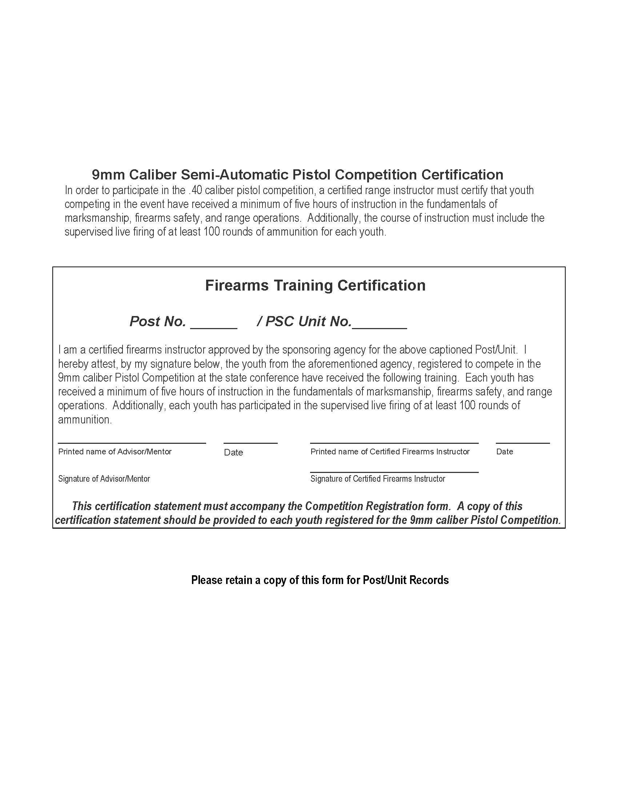

CODE OF CONDUCT
This code of conduct applies to all youth and adults.

The program’s leadership (adult leaders and youth leadership) will be responsible for maintaining discipline and security at all times. Adults and youth will be guided by their department's SOP and will obey all local and state laws.

Youth will set a good example by keeping themselves neatly dressed and presentable. Wearing of clothing identifying your program is encouraged.

The purchase, possession and consumption of alcoholic beverages or illegal drugs by youth or adult participants is not permitted.

Gambling in any form is not permitted.

Possession of firearms or any device that fires any type of projectile, including but not limited to airsoft, bb, paintball, (this is not to exclude items used for competition and are supplied by the host) or fireworks is prohibited by youth and adults.

Youth and adults will demonstrate respect for Pickens High School property and be personally responsible for cleanliness and any loss, breakage, or theft of property.

Neither the Pickens County School Board nor LEEAG will be responsible for the loss, breakage or theft of personal items.

Food and beverages are not permitted in the classrooms. Smoking is prohibited inside the facilities; tobacco chewing is regarded as an outside activity. Smoking by persons under the legal age will not be tolerated.

Youth will at all time show respect to all adults, instructors, and event staff.

Youth staying at local hotels will show proper respect for hotel property and personnel, and rules. Youth and adults are responsible for any damage to hotels. Hotel curfew is 23:00 unless otherwise approved by adult leaders.

All medical issues need to be reported to the adult leaders and then reported to a LEEAG staff member

Violations of this code are subject to be brought before the LEEAG Discipline Board. The Board's decision on all matters will be final and there will be no appeal.

For value received, I hereby consent to the use of my (or his/her) name, voice and/or pictures by the Law Enforcement Experience Association of Georgia, and/or any movie, news, or broadcasting companies or their licensees for broadcasting, direct exhibition, and subsidiary purposes. Such uses will not be made which would constitute a direct endorsement by said Explorer/Cadet of any product or service. I hereby agree to indemnify the Law Enforcement Experience Association of Georgia, my local Learning for Life office, and the Public Safety Cadets officers, employees, agents, or their representatives, and any other person working under the director or engaged in the conduct of their affairs, said movie or broadcasting companies and their licensees representing any claim arising out of my or said youth’s acts or statements. I have read the Code of conduct and agree to the rules and regulations therein.

This Code of Conduct is subject to amendment at any time by the LEEAG Executive Board. All youth must be aware that their adult leaders may put further restrictions on their behavior and/or activities at any time during the conference. Such restrictions will be adhered to as if incorporated into
this Code of Conduct.

(SIGNATURE)

(SIGNATURE OF PARENT OR GUARDIAN IF UNDER 18)

STATE OF GEORGIA, COUNTY OF PICKENS

COVENANT NOT TO SUE
For the consideration of my participation in the Law Enforcement Experience Association of
GA (LEEAG) State Conference, I,

(PRINT YOUR NAME HERE)
enter into the following covenant:
I do hereby agree not to sue the State of Georgia, the Georgia Peace Officers Standards and
Training Council, the Pickens County School Board, the Law Enforcement Experience Association of Georgia, sponsoring and member agencies and programs of the Law Enforcement
Experience Association of Georgia, Learning For Life, Public Safety Cadets or any of their respective advisory boards, agents, employees, or assignees, for any reason arising from my participation in this
event.
This Covenant Not To Sue shall be binding upon myself, my heirs, the administrator or
executor of my estate or upon any other acting on behalf of myself or my estate. It is
expressly understood that this covenant is entered into for the purpose of avoiding litigation
and is a prerequisite to my participation in this event. This Covenant Not To Sue may be
placed as a defense to any action or proceeding which may be brought, instituted, or taken by
me, my heirs, the executor or administrator of my estate, and any others acting on my behalf.
I expressly assume the risk and responsibility, including, but not limited to, the financial
responsibility, for any injury that I may receive while participating in this event. This
Covenant Not To Sue shall cover, but not be limited to, acts of negligence, either by
commission or omission, of any type, kind or nature.
I hereby state that I am under no disability to contract and have read and understood this
Covenant Not To Sue and have entered into it voluntarily.
This Covenant Not To Sue shall remain in effect during the inclusion dates of this event, but
may be canceled by written notice, properly directed to and received by the Director of the
Georgia Public Safety Training Center and the Executive Director of the Law Enforcement
Experience Association of Georgia.
This Covenant Not To Sue is made and entered into this the day of ,
20__.

(SIGNATURE)

(SIGNATURE OF PARENT OR GUARDIAN IF UNDER 18)
Youth Officer Board Duties
State Youth President:
The State Youth President shall preside over meetings, such as LEEAG State Delegate meetings, LEEAG Youth Committee meetings, LEEAG Youth Officer Board Meetings, and the LEEAG State Conference.

State Youth Vice Presidents:
The State Youth Vice Presidents shall act as a board of directors under the leadership of the State Youth President. One vice president shall be elected from each of the six regions of the Association. However, if, at the time of elections, one or more regions is not represented by any post from within that region, one or more vice presidents may be elected as “at-large” vice presidents and assigned to the region not represented.

State Youth Chaplin:
The State Youth Chaplain shall give the invocation and benediction at each LEEAG State function. This officer is a non-voting member of the Youth Officer Board

Law Enforcement Experience Association of Georgia
State Officer Nomination Form
Name:
Post/Unit #:
Agency:
Region:

Position:

